

The information in this document is confidential and meant to be used only by the intended or authorized owner, it contains confidential, proprietary, or legally privileged information. No confidentiality or privilege is waived or lost by any miss-transmission. If you receive this document in error, please immediately delete it and all copies of it, destroy any hard copies of it and notify the  
TIMWETECH. You must not, directly, use, disclose, distribute, print, or copy any part of this message if you are not the intended or authorized owner.



Presented by:

TIMwe Asia Pacific Sdn Bhd

Suite 18-02, Level 18, GTower 199 Jalan Tun Razak, 50400, Kuala Lumpur, Malaysia

Business Request

Module: Target KPI & Achievement Aggregation

CR#21517 -KPI's NOM, Q-URO, Q-SSO, DSF MP w HADOOP integration

Version 1.0

October 26, 2020

CONTENTS

VERSION HISTORY 3

REFERENCES 3

SUMMARY 4

Current Solution 4

Business & Functional Requirements 5

Business Reason & Benefit 5

BUSINESS & FUNCTIONAL REQUIREMENTS 6

1. Change: Number of Outlet Mobo (Custom KPI) 6

Current Solution 6

New Requirements 6

Calculation Example 6

2. Enhancement: Q-URO for MPC (Custom KPI) 7

Current Solution 7

New Requirements 7

Calculation Example 8

3. Enhancement: Q-URO for CSO (Custom KPI) 9

Current Solution 9

New Requirements 9

Calculation Example 9

Enhancement: Q-SSO for MPC (Custom KPI) 10

Current Solution 10

New Requirements 10

Calculation Example 11

4. Enhancement: Q-SSO for CSO (Custom KPI) 12

Current Solution 12

New Requirements 12

Calculation Example 12

5. Enhancement: DSSF Manpower (Custom KPI) 13

Current Solution 13

New Requirements 13

Calculation Example 13

6. Enhancement: Additional KPI Validation Reports 14

6.1. Detail KPI Validation Report – Q-URO 14

6.2. Detail KPI Validation Report – Q-SSO 14

6.3. Detail KPI Validation Report – DSSF ATTENDANCE 14

IMPACT ASSESSMENT 15

Impacted Modules 15

Integration & Interfaces 15

Data changes & Migration 15

Reports & Data Dumps 15

Communication interfaces 15

Hardware & Infrastructure 15

ANNEXURES 16

Appendix A: Open Issues 16

APPROVAL SIGN-OFF 17

E-mail approval screen captures 18

# VERSION HISTORY

|  |  |  |  |
| --- | --- | --- | --- |
| VERSION | DATE | CHANGE | BY |
| 1.0 | 26/10/2020 | Release for approval | Romet Roosalu |
|  |  |  |  |
| 0.1 | 22/10/2020 | Creating of document | Parthipan Rajagopal |

# REFERENCES

Referenced document names or links:

|  |  |  |
| --- | --- | --- |
| DOCUMENT | DESCRIPTION | COMMENT |
|  | Integrated Business Requirement Specification document | From: Amri Setiadi  Sent: Thursday, 19 October 2020 6:50 PM |

# SUMMARY

## Current Solution

In current MOBII module ‘Target KPI & Achievement Aggregation’, various Key Performance Indexes (KPI’s) are developed which are used for Incentive & Commission calculation, as next:

* **Custom KPI (C-KPI)**  
  These KPI’s are having pre-defined logic, where calculation logic cannot be influenced by the Business User. Custom calculation methodology is defined by INDOSAT and built into MOBII module “Target KPI & Achievement Aggregation” by developers. Data source for these KPI’s can be internal MOBII event/transaction or external (HADOOP, DWH etc.) file-feed data.
* **Accumulated KPI (A-KPI)**Where Accumulated KPI (Parent KPI) achievements is calculated from multiple KPI (Child KPI) achievements
* **Derived KPI (D-KPI)**Derived KPI is dependent KPI (Parent KPI), where result derived from multiple KPI (Child KPI), based on Business User defined logic. The Business User can define calculation logic, using following methods:  
  + **By Weightage**Where Business User can select multiple KPI’s and provide the weightage % for each KPI, to aggregate final delivered value.
  + **By Slab**Where Business User can be defined on the value ranges of a child KPI. For each slab, an associated derived KPI value will be provided
  + **By Expression**Where user can build the formulas based on expression
* **Upload (U-KPI)**

Where Business User can define the template, to upload KPI data into the MOBII system.

## Business & Functional Requirements

INDOSAT Channel Team as Business User requested from MOBII team to develop additional KPI’s in Target KPI & Achievement Aggregation module, as an Enhancement Requests:

1. To enhance MOBII capability to calculate new KPI parameter and fulfill dynamic KPI from Management INDOSAT and following new definition for current condition.
2. The additional KPI parameter will automate calculation which predefined parameter and applied to CSO & MPC.
3. Below KPI parameters will be introduced in MOBII:
   1. Number of Outlet MOBO;
   2. Q-URO;
   3. Q-SSO;
   4. Manpower for SF Attendance on Simple Apps.
4. Next Additional Reports to develop in Analytics & Reports module, as Enhancement requests:
   1. Detail KPI Validation Report – Daily Q-URO;
   2. Detail KPI Validation Report – Daily Q-SSO;
   3. Detail KPI Validation Report – Daily Attendance DSSF.
5. Change in Integration with Surroundings module, as Change Request:
   1. INTHDP004 – Daily Sim Selling Outlet (DSSO), where HADOOP will introduce additional column ‘QSSO_STATUS’.
   2. INTHDP017 – URO 20K, where HADOOP will introduce additional column ‘QURO_STATUS’.
6. New Integration with Surroundings module, as Change Request:
   1. INTHDP023 – DSSF Attendance, where HADOOP will introduce new file feed for this

## Business Reason & Benefit

Business & Functional Requirements are part of Nov’20 ISAT Incentive & Commission policy and registered as additional request from BU with ID #21517

# BUSINESS & FUNCTIONAL REQUIREMENTS

## Change: Number of Outlet Mobo (Custom KPI)

### Current Solution

**In current MOBII version, “NOM” KPI is implemented for CSO Position, where achievement is calculated based on current month total operator mapping cut of at 5th of each month.**

### **New Requirements**

**INDOSAT KPI team requires to change KPI, with next requirements:**

* 1. **Existing NOM KPI logic will be updated.**
  2. **Target can be uploaded at cluster level which means as part of MPC incentive target this KPI target can be uploaded.**
  3. **Actual achievement will be calculated based on outlet operator mapping under each MPC organization.**
  4. **Current month achievement is calculated based on current operator mapping (D-1) of same month and up to 5th of the next. If the KPI month is already crossed 5th of next month then next month 5th cut off will be consider as final value.**
  5. **MOBII can use the same existing monthly aggregation report and operator mapping from additional report to validate this.**

### **Calculation Example**

**After next month 5th cut off:**

|  |  |  |  |  |
| --- | --- | --- | --- | --- |
| **CLUSTER** | **TARGET NOM NOVEMBER** | **ACTUAL MAPPING  on 5th DEC** | **ACHIEVEMENT NOM NOVEMBER = ACTUAL MAPPING  on 5th DECEMBER divided by TARGET NOM NOVEMBER** | **FINAL SCORE NOM CLUSTER NOVEMBER = SCORE NOM CSO NOVEMBER** |
| **A** | 1,455 | 1,457 | 1457/1455 x 100% = 100.14% | 100.14% |
| **B** | 1,470 | 1,465 | 1465/1470 x 100% = 99.66% | 99.66% |
| **C** | 1,105 | 1,120 | 1120/1105 x 100% = 101.36% | 101.36% |
| **D** | 1,200 | 1,220 | 1,220/1,220 x 100% = 98.36% | 98.36% |

**Sample calculation in current Month:**

|  |  |  |  |  |
| --- | --- | --- | --- | --- |
| **CLUSTER** | **TARGET NOM NOVEMBER** | **ACTUAL CURRENT MAPPING (D-1)** | **ACHIEVEMENT NOM NOVEMBER = ACTUAL MAPPING  divided by TARGET NOM NOVEMBER** | **SCORE NOM CLUSTER NOVEMBER = SCORE NOM CSO NOVEMBER** |
| **A** | 1,455 | 1,257 | 1257/1455 x 100% = 86.39% | 86.39% |
| **B** | 1,470 | 1,265 | 1265/1470 x 100% = 86.05% | 86.05% |
| **C** | 1,105 | 1,020 | 1020/1105 x 100% = 92.31% | 92.31% |
| **D** | 1,020 | 1,120 | 1020/1120 x 100% = 91.07% | 91.07% |

## Enhancement: Q-URO for MPC (Custom KPI)

### Current Solution

**In current MOBII version, KPI is calculated for URO 20 only.**

### **New Requirements**

**INDOSAT KPI team requires new KPI for MPC incentive, with next requirements:**

* 1. **KPI will be assigned to the MPC position.**
  2. **KPI achievement will be calculated for Monthly.**
  3. **Target will be uploaded to each MPC using MPC Incentive target template.**
  4. **Actual will be calculated based on HADOOP feed INTHDP017. This interface will be added with new field QURO_STATUS. For detailed information about data type we can refer HADOOP IDD document.**
  5. **HADOOP file contains following fields *DATE|MICRO|SITE_ID|OUTLET|HIT|AMOUNT|QURO_STATUS;***
  6. **QURO_STATUS possible values are 1 or 0. If value is 1 then given outlet is counted as QURO.**
  7. **Maximum 20 outlets will be considered from each site under each MPC. This 20 is not fixed can be uploaded via site target template against each site.**
  8. **Sum of final outlet counts from each site will be considered as final achievement of MPC.**
  9. **All outlets from HADOOP file should be consider for given site and micro cluster.**
  10. **IF any outlet is given under multiple micro clusters or multiple sites then specific outlet will be counted for all corresponding site and micro cluster.**
  11. **If any SITE is not uploaded with target value or target value set as 0 then no outlets under this site from HADOOP file will be counted for MPC.**
  12. **If HADOOP data not contains site code then it will not be considered for any MPC. If required in future should able to consider all the outlets without site info in HADOOP file.**
  13. **IF micro cluster is empty or not found in MOBII it cannot be counted for any MPC.**
  14. **MPC is identified based cluster and cluster is identified based on micro cluster from HADOOP data and this mapping followed corresponding KPI month snapshot.**
  15. **HADOOP sample data,**

***DATE|MICRO|SITE_ID|OUTLET|HIT|AMOUNT|QURO_STATUS***

***20201001|MC-KEPANJEN|20BTU264|17225807|8|227000|1***

***20201001|MC-BANYUMAS KAB|14PWT133|1506546|234|6351250|0***

* 1. **MOBII should provide Additional Reports, details available in section 7.1**

### **Calculation Example**

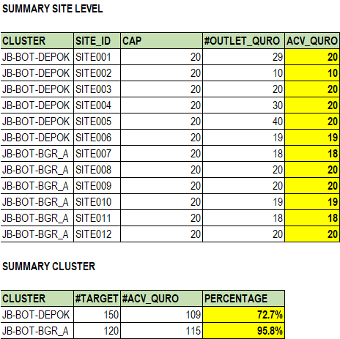

## Enhancement: Q-URO for CSO (Custom KPI)

### Current Solution

**In current MOBII version, KPI is calculated for URO 20 only.**

### **New Requirements**

**INDOSAT KPI team requires new KPI for CSO incentive, with next requirements:**

* 1. **KPI will be assigned to the CSO position.**
  2. **KPI achievement will be calculated for Monthly.**
  3. **Target will be uploaded to each CSO using CSO Incentive target template.**
  4. **Actual will be calculated based on HADOOP feed INTHDP017. This interface will be added with new field QURO_STATUS. For detailed information about data type we can refer HADOOP IDD document.**
  5. **HADOOP file contains following fields *DATE|MICRO|SITE_ID|OUTLET|HIT|AMOUNT|QURO_STATUS;***
  6. **QURO_STATUS possible values are 1 or 0. If value is 1 then given outlet is counted as QURO.**
  7. **CSO will be identified based outlet operator mapping with cut of 5th of corresponding KPI month.**
  8. **All outlets from HADOOP file will be consider which is mapped with CSO (No FISIK filter).**
  9. **HADOOP sample data,**

***DATE|MICRO|SITE_ID|OUTLET|HIT|AMOUNT|QURO_STATUS***

***20201001|MC-KEPANJEN|20BTU264|17225807|8|227000|1***

***20201001|MC-BANYUMAS KAB|14PWT133|1506546|234|6351250|0***

* 1. **MOBII should provide Additional Reports, details available in section 7.1**

### **Calculation Example**

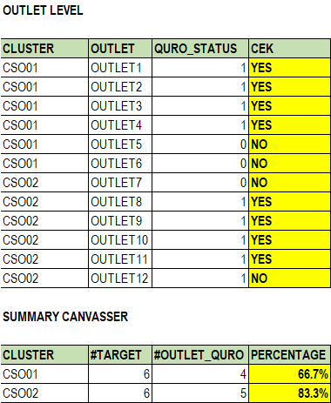

## Enhancement: Q-SSO for MPC (Custom KPI)

### Current Solution

**In current MOBII version, KPI is calculated for SSO only.**

### **New Requirements**

**INDOSAT KPI team requires new KPI for MPC incentive, with next requirements:**

* 1. **KPI will be assigned to the MPC position.**
  2. **KPI achievement will be calculated for Monthly.**
  3. **Target will be uploaded to each MPC using MPC Incentive target template.**
  4. **Actual will be calculated based on HADOOP feed INTHDP004. This interface will be added with new field QSSO_STATUS. For detailed information about data type we can refer HADOOP IDD document.**
  5. **HADOOP file contains following fields *DATE|MICRO|SITE_ID|ID_OUTLET|QTY|AMOUNT|QSSO_STATUS;***
  6. **QSSO_STATUS possible values are 1 or 0. If value is 1 then given outlet is counted as QSSO.**
  7. **Maximum 20 outlets will be considered from each site under each MPC. This 20 is not fixed can be uploaded via site target template against each site.**
  8. **Sum of final outlet counts from each site will be considered as final achievement of MPC.**
  9. **All outlets from HADOOP file should be consider for given site and micro cluster.**
  10. **If any outlet is given under multiple micro clusters or multiple sites then specific outlet will be counted for all corresponding site and micro cluster.**
  11. **If any SITE is not uploaded with target value or target value set as 0 then no outlets under this site from HADOOP file will be counted for MPC.**
  12. **If HADOOP data not contains site code then it will not be considered for any MPC. If required in future should able to consider all the outlets without site info in HADOOP file.**
  13. **If micro cluster is empty or not found in MOBII it cannot be counted for any MPC.**
  14. **MPC is identified based cluster and cluster is identified based on micro cluster from HADOOP data and this mapping followed corresponding KPI month snapshot.**
  15. **HADOOP sample data,**

***DATE|MICRO|SITE_ID|ID_OUTLET|QTY|AMOUNT|QSSO_STATUS***

***20201001|MC-KUDUS|14COW001|17163165|1|11700|1***

***20201001|MC-BEKASI SELATAN|03CKR204|1076376|2|21500|0***

***20201001|MC-DEMAK|14DMK044|582651|4|46800|1***

* 1. **MOBII should provide Additional Reports, details available in section 7.2**

### **Calculation Example**

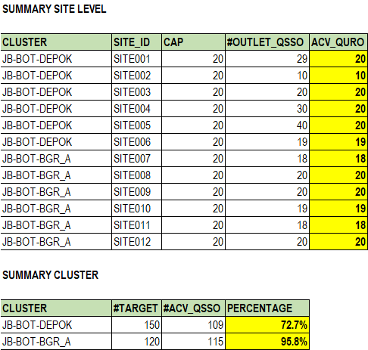

## Enhancement: Q-SSO for CSO (Custom KPI)

### Current Solution

**In current MOBII version, KPI is calculated for SSO only.**

### **New Requirements**

**INDOSAT KPI team requires new KPI for CSO incentive, with next requirements:**

* 1. **KPI will be assigned to the CSO position.**
  2. **KPI achievement will be calculated for Monthly.**
  3. **Target will be uploaded to each CSO using CSO Incentive target template.**
  4. **Actual will be calculated based on HADOOP feed INTHDP004. This interface will be added with new field QSSO_STATUS. For detailed information about data type we can refer HADOOP IDD document.**
  5. **HADOOP file contains following fields DATE|MICRO|SITE_ID|ID_OUTLET|QTY|AMOUNT|QSSO_STATUS;**
  6. **QSSO_STATUS possible values are 1 or 0. If value is 1 then given outlet is counted as QSSO.**
  7. **CSO will be identified based outlet operator mapping with cut of 5th of corresponding KPI month.**
  8. **All outlets from HADOOP file will be consider which is mapped with CSO (No FISIK filter).**
  9. **HADOOP sample data,**

**DATE|MICRO|SITE_ID|ID_OUTLET|QTY|AMOUNT|QSSO_STATUS**

**20201001|MC-KUDUS|14COW001|17163165|1|11700|1**

**20201001|MC-BEKASI SELATAN|03CKR204|1076376|2|21500|0**

**20201001|MC-DEMAK|14DMK044|582651|4|46800|1**

* 1. **MOBII should provide Additional Reports, details available in section 7.2**

### **Calculation Example**

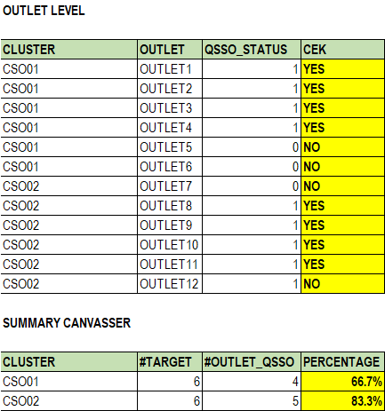

## Enhancement: DSSF Manpower (Custom KPI)

### Current Solution

**In current MOBII version, Manpower KPI is calculated only based MOBII internal data.**

### **New Requirements**

**INDOSAT KPI team requires new KPI for MPC incentive, with next requirements:**

* 1. **KPI will be assigned to the MPC position.**
  2. **KPI achievement will be calculated for Monthly.**
  3. **Two targets will be uploaded to each MPC.**

1. **Threshold on visit days field**
2. **Number of** PROGMOTER_ORG_ID who is achieved threshold.
   1. **Actual will be calculated based on HADOOP feed INTHDP023. This interface will contain DSSF user visit activities using other applications.**
   2. **HADOOP file contains following fields**

DATE|CLUSTER|PROGMOTER_ORG_ID|CHECKIN_TYPE|QTY**;**

* 1. **Since these PROMOTER_ORG_ID is not registered with MOBII. So given id will be counted as achievement for MPC when the given** PROGMOTER_ORG_ID **unique visited days are equal or more than threshold target. Here visit days can be included for all CHECKIN_TYPE, if required operationally filter can be added in future.**
  2. **If threshold target is not set for any cluster (which means null from initial) then MPC man power is 0. If target is set 0 by user then if user visiting 1 day is considered as achieved.**
  3. **MPC will be identified based on cluster description.**
  4. **HADOOP sample data,**

*DATE|CLUSTER|PROGMOTER_ORG_ID|CHECKIN_TYPE|QTY*

***20201001|CL-KUDUS|17163165|On Location|10***

***20201001|CL-KUDUS|17163165|Outside Location|5***

* 1. **MOBII should provide Additional Reports, details available in section 7.3**

### **Calculation Example**

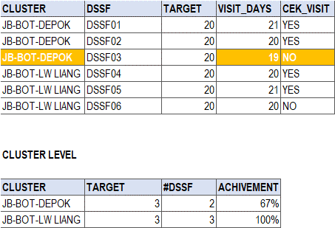

## Enhancement: Additional KPI Validation Reports

### **Detail KPI Validation Report – Q-URO**

MONTH_ID|REGION|AREA|SALES AREA|CLUSTER|MICRO CLUSTER|DEALER REF CODE|DEALER ORG ID|DEALER ORG NAME|SITE_ID|CSO CODE|CSO NAME|OUTLET CODE|OUTLET NAME|QURO STATUS|LATEST DATE

Note: Outlet without mapping also should be part of this report

### **Detail KPI Validation Report – Q-SSO**

MONTH_ID|REGION|AREA|SALES AREA|CLUSTER|MICRO CLUSTER|DEALER REF CODE|DEALER ORG ID|DEALER ORG NAME|SITE_ID|CSO CODE|CSO NAME|OUTLET CODE|OUTLET NAME|QSSO STATUS|LATEST DATE

Note: Outlet without mapping also should be part of this report

### **Detail KPI Validation Report – DSSF ATTENDANCE**

DATE|REGION|AREA|SALES AREA|CLUSTER|MICRO CLUSTER|DEALER REF CODE|DEALER ORG ID|DEALER ORG NAME|PROGMOTER_ORG_ID|CHECKIN_TYPE|QTY

# IMPACT ASSESSMENT

## Impacted Modules

|  |  |  |  |
| --- | --- | --- | --- |
| IMPACT | MODULE | DESCRIPTION | CR #ID |
| No | User, Organization & Masters |  |  |
| No | Product, Price & Discount Management |  |  |
| No | Warehouse & Inventory Management |  |  |
| No | Sales Management |  |  |
| No | Journey Plan & Visit Management |  |  |
| No | Geographic Information System (GIS) |  |  |
| Yes | Target KPI & Achievement | Change 1 KPI and introduction 5 new KPI’s as enhancements | 21517-09 |
| Yes | Incentive & Commission | Change in calculation and incentive plan core logic | 21517-09 |
| Yes | Analytics & Reporting | Change in 2 reports and introduction 3 new Detail KPI validation reports as enhancements | 21517-09 |
| No | Mobile Application (Android) |  |  |
| No | Integration with IDM |  |  |
| No | Integration with FOSS |  |  |
| No | Integration with TNM |  |  |
| No | Integration with MOBO |  |  |
| No | Integration with SAP |  |  |
| No | Integration with RA-FMS |  |  |
| No | Integration with DWH |  |  |
| Yes | Integration with HADOOP | Change of 2 current interfaces and introduction 1 new interface. | 21517-80 |

## Integration & Interfaces

The table below provides list of interfaces with high-level impact description.

|  |  |  |  |
| --- | --- | --- | --- |
| NO | ID | INTERFACE NAME | IMPACT |
|  | INTHDP004 | DSSO | HADOOP will introduce additional data field/column. |
|  | INTHDP017 | USR20 | HADOOP will introduce additional data field/column. |
|  | INTHDP023 | DSSF ATTENDANCE | HADOOP will introduce new interface |

## Data changes & Migration

No changes required

## Reports & Data Dumps

* Five (5) additional Reports to develop in Analytics & Reports module, as Enhancement requests.

## Communication interfaces

No changes required

## Hardware & Infrastructure

No changes required

# ANNEXURES

## Appendix A: Open Issues

In this section are all unresolved issues, TBDs, pending decisions, findings required, conflicts, etc.

|  |  |  |  |
| --- | --- | --- | --- |
| ID | DESCRIPTION | RESPONSIBLE | STATUS |
|  |  |  |  |

# APPROVAL SIGN-OFF

I have received soft copy of current version document via e-mail, reviewed and approved confirm with reply to e-mail and as undersigned, I change request and agree that it’s appropriate:

|  |  |  |
| --- | --- | --- |
| 1. **PARTHIPAN RAJAGOPAL** Business Analytic (TIMWE) |  |  |
|  | Signature | Date |
| 1. **ROMET ROOSALU** Project Manager (TIMWE) |  |  |
|  | Signature | Date |
| 1. **AMRI SETIADI** Business User (INDOSAT) |  |  |
|  | Signature | Date |
| 1. **BUDI PRIYAMBODO** Business User (INDOSAT) |  |  |
|  | Signature | Date |

## E-mail approval screen captures